Section 4

Team 59

Kathryn Atherton

Ryan Hellyer

Natalie Zimmermann

November 6, 2015

Dr. Francis S. Collins

Director, National Institute of Health

9000 Rockville Pike

Bethesda, MD 20892

Dear Dr. Francis S. Collins,

Advanced Additive Manufacturing Commercialization’s primary goal in working on this project was to create a model to calculate the optimal Print Head Speed, Print Aperture, and Culture Temperature for each part the NIH expects the bioprinter to produce, using the inputs of the part volume, tolerance, and factor of safety. Thus, the operation of the bioprinter is much more straightforward, so that a lab technician, rather than a scientist, can print the parts needed, making the operation of the bioprinter more cost-effective in the process.

Along with the model, AAMC developed a method for determining the Factor of Safety for various parts expected to be produced by the bioprinter. Recommended Factors of Safety for the parts that the NIH asked AAMC to expect to be produced are included in the enclosed report. These Factors of Safety are used to over-engineer the necessary parts so as to prevent the bioprinter from producing part errors greater than the part tolerances, which will be detrimental to the part’s ability to be safely used.

Sincerely,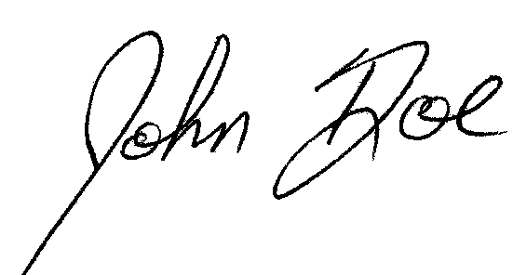

John Doe

Advanced Additive Manufacturing Commercialization, Head of Modeling Team

Enclosed: Executive Summary, Model Development Process, Conclusion and Recommendation

**Executive Summary**

The task of Advanced Additive Manufacturing Commercialization was to create a model of the operation of a bioprinter, taking into account the volume, tolerance, and Factor of Safety of the part to be created by the bioprinter, as well as develop recommended Factors of Safety for each part expected to be produced. Before the creation of the model began, the data obtained from the National Institute of Health was cleaned. The Experimental Error notes provided by the NIH were examined and then skewed or miscalibrated points were eliminated or adjusted based on the conclusions drawn from these notes. Once the data was cleaned, regression lines were calculated, based on the shapes of the cleaned graphs. The print head speed versus dimensional error graph was found to be linear, so the Method of Least Squares was used in order to find a regression line. The print aperture versus dimensional error graph was found to be exponential, and the culture temperature versus dimensional error graph was found to be a power function, so Microsoft Excel was used to find the regression lines for these relationships.

Once these regression relationships were found, the model was created. The inputs were first defined and converted into the units needed for the outputs and calculations, the development of the model began. The Factor of Safety and part tolerance inputs were used to calculate the estimated dimensional error. Then, the regression lines determined were used to calculate the optimal printer head speed, print aperture, and culture temperature from the estimated dimensional error, as well as the original maximum part tolerance; however, the program assumed that one can solve for each factor contributing to dimensional error from its respective regression model, rather than cumulatively considering the sources of the dimensional error in this process. It was also assumed that the dimensional error is only affected by the head speed, print aperture, and culture temperature. From these variables, the printing and cure times were found, and the production time is determined. The cost of production was calculated with and without the Factor of Safety taken into account, and then the difference in cost between the two situations was found. The program then output the calculated values for head speed, print aperture, culture temperature, estimated dimensional error, production time, cost due to the Factor of Safety, and total cost.

Recommended operation settings for each part can be found in Tables 2 and 3, below. A formula for finding the Factor of Safety for specific parts was developed.

**Model Development Process**

In order to understand the functioning of the bioprinter, the different variables that influence its performance, and their relationship were analyzed, as can be seen in Figure 1 and Figure 2. Once the variables were analyzed, the next step was to organize the data and equations provided by the NIH in order to understand how the variables were related. The first problem that appeared was how to relate the dimensional error from each part to the exact print head speed, culture temperature, and the print aperture. The NIH provided three graphs that related the different factors to the total dimensional error.

Data cleaning was performed before beginning the modeling process or determining the exact relationship between the variables in the data provided by the NIH. In order to clean the experimental data properly the Error Measurement Notes provided with the Initial Notes from the NIH were taken into account. The data was manipulated as follows:

-Print Head Speed vs. Dimensional Error

1- Points with speed 0 were removed because dimensional error is impossible when the printer head is stationary.

2- Decreased the dimensional error values of all points by 0.1mm because comparisons with known results indicated the presence of calibration error, so dimensional error was consistently 0.1mm high.

3- Deleted the data point (1.850, 1.105 ) because an intern tripped and fell on the machine, thereby skewing the data.

4- Deleted data points 57 and 58 because a leak occurred during that time, and the impact of such a leak on the performance of the printer is unknown.

-Print Aperture vs. Dimensional Error

1- Added 0.1mm to all print aperture values because some print aperture values were negative, which indicates calibration error.

2- Deleted points where aperture was 0 as they did not indicate anything about the actual performance of the printer.

-Culture Temperature vs. Dimensional Error

1- Deleted data points 16 through 18 because an intern was doing jumping jacks in the lab, which skewed results during a short period.

2- Deleted data point 123, which had extremely high error from the floor shaking due to transportation of heavy objects.

3- Deleted data points before 4ºC and after 36ºC, as the model does not apply for values out of the range [4, 36].

After the data was cleaned, the regression line that related the different variables to the dimensional error was found. The relationship between the Print Head Speed and the Dimensional error is linear, and the line of best fit was found utilizing the Method of Least Squares. The final equation for this graph (Figure 6):

y = 0.3422x

Coefficient of determination (R2) = 0.99002

Both the culture temperature and the print aperture did not fit a linear model. As a result, Microsoft Excel was employed to find the line of best fit for these data sets. The print aperture and the dimensional error fit an exponential model, with the following equation (Figure 4):

y = 0.0054e2.9094x

Coefficient of determination (R2) = 0.99849

Finally, the culture temperature and the the dimensional error fitted a power function with the following values (Figure 5):

y = 0.00002x3.2563

Coefficient of determination (R²) = 0.99804

Using these models and a user input for the admitted tolerance, and the volume of a specific part, the optimal print speed, print aperture and culture temperature can be found. Knowing that the printing time is directly proportional to the part volume, and inversely proportional to the print head speed and the print aperture, and that the cure time satisfies the following equation:

$$Cure Time =20 + \frac{1570}{Temperature}$$

it is possible to calculate the exact time it will take to print and cure a desired part.

When finding the final production time, first the cure time and the printing time are compared. If the printing time is greater or equal to the cure time, the final production time is found adding 20 minutes to the printing time. Otherwise, the final production time equals the previously calculated cure time.

There are two main factors influencing the final cost of a part. Firstly, there is the time needed to produce the part, which is $18 per minute of production. Secondly, there is the cost of the material used in the printing process. Currently, that price lies at $500 per cubic centimeter (cm3).

This model would work perfectly if there were no unpredictable factors. As the model presented does not account for unforeseen scenarios, external factors, and random error in the regression lines, a factor of safety must be established. In this specific case, a factor of safety is used to reduce the dimensional error. In other words, each part has a specific tolerance, and if there were no factor of safety the printer would work in a way to produce a part with exactly that deviation. But, if there were an unforeseen external factor that could influence the printer’s performance, the part produced would not conform to the required specifications. Thus, a factor of safety allows for this random error to occur without affecting the quality of the part.

The target dimensional error must be smaller than the part tolerance. Therefore, the tolerance was divided over the factor of safety. Then, even in a worst scenario, the tolerance limits will be met.

The factor of safety will influence the cost and the production time of the part. A smaller dimensional error also means a slower printing process and a smaller print aperture, which would then result in a higher printing time and a higher cost. A balance between the factor of safety, the printing time and the total cost must be found.

The factor of safety was found using the following formula:

Factor of Safety = [1 + (0.45)(Ratio of Part Volume to Part Tolerance/6000)]*(1.3)*(100%)

This formula was developed by taking into account three factors: the accuracy of the regression models, the ratio of part volume to part tolerance, and unforeseen external factors.

To take into account the accuracy of the regression models, the average of the R2 values were calculated and then subtracted from 1. This represented the error that could not be accounted for in the model. A ratio of this error versus the behavior that could be modeled by the regression models was taken. This value (0.45) was then incorporated into the Factor of Safety formula.

To take into account the ratio of part volume to part tolerance, these ratios were calculated for each part. Then, the ratios were scaled down to find proportions between the ratios of the parts. As 6000 mm3/mm was the smallest ratio for one part, each ratio was divided by this value, as seen in Table 1. These proportions were then incorporated into the Factor of Safety formula.

Finally, to take into account the unforeseen errors that may occur in production, such as those that occurred during the dimensional error tests done by the NIH, an extra 30% of the already calculated error was included into the Factor of Safety formula.

The program created then outputs the different variables calculated, head speed, aperture, temperature, production time, dimensional error, added cost, and total cost, as can be seen in Figure 3.

**Conclusion and Recommendations**

Bioprinting is a new technique that needs further research and development in order to improve the performance, minimizing the cost, and reducing the error of the printer. If the overall performance can be improved, the ease of operation will be increased, which would reduce the training needed to operate the machine and decrease the overall cost of operation of the bioprinter.

The capabilities of Advanced Additive Manufacturing Commercialization’s model allows for this decrease in cost of operation. As the optimal printer head speed, print aperture, and culture temperature are easily computed for any desired part, an expert on bioprinting is not required to operate the machine. Rather, a technician can run the model with the given parameters of the part, be told the optimal settings for the bioprinter, and then create the desired part with little training.

Additionally, as the capabilities of the bioprinter develop, and more parts are able to be produced, the derived formula for the Factor of Safety for each part can be used to find an appropriate value for the Factor of Safety in the future. Thus, preventing the production of faulty parts as the bioprinter continues to reach its full potential in the medical field.

Although the additional costs due to the Factor of Safety may appear to be high for some parts, as the formula for the Factor of Safety accounts for unforeseen errors in production, such as a printer leak, or the moving of heavy machinery near the bioprinter, resources and money will be saved in the long run. This is because if any of these errors do occur, the Factor of Safety effectively prevents the creation of unsafe parts. Without this buffer created by the Factor of Safety, defective parts are more likely to be produced, which must be thrown away, thus wasting culture resources as well as money.

Recommendations of operation for specific parts can be found in Tables 2 and 3. However, more research will be necessary as the bioprinter continues to develop its capabilities, within the medical field, as well as in other areas of application.

**References**

Larry, NIH Internal Synthetic Biology Skunkworks Group, personal communication, October 21, 2015

John Doe Signature. (n.d.). Retrieved November 6, 2015, from http://usercontent2.hubimg.com/7697087.gif

National Institute of Health, *Project 2 Day 2 - Appendix C* (Excel Workbook), Retrieved from Blackboard Learn, Engineering 14100, Project 2 Folder

**Appendix**

**Figure 1: Flowchart of Influences on Variables**

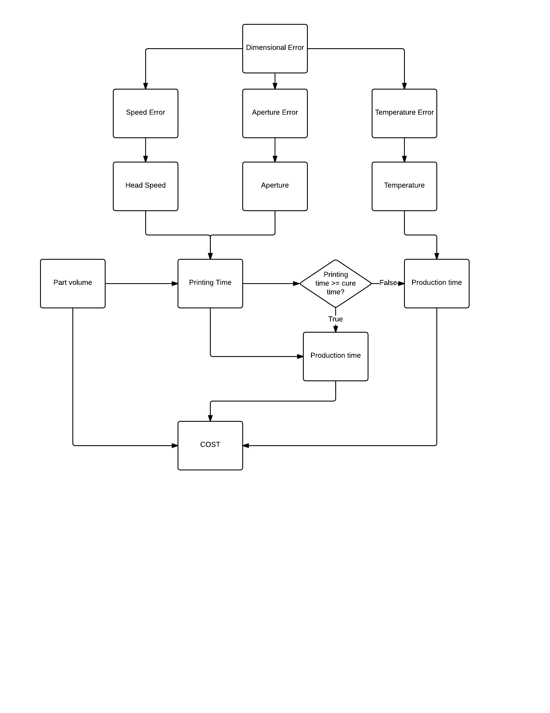

**Figure 2: Relationship of Variables**

|  |  |  |  |  |  |  |  |  |  |  |
| --- | --- | --- | --- | --- | --- | --- | --- | --- | --- | --- |
|  | DE | SE | AE | TE | Speed | Apert | Temp | Vol. | Print time | Cost |
| DE |  | + | + | + | + | + | + |  | - | - |
| SE | + |  |  |  | + |  |  |  | - | - |
| AE | + |  |  |  |  | + |  |  | - | - |
| TE | + |  |  |  |  |  | + |  | - | - |
| Speed | + | + |  |  |  |  |  |  | - | - |
| Apert | + |  | + |  |  |  |  |  | - | - |
| Temp | + |  |  | + |  |  |  |  | - | - |
| Vol |  |  |  |  |  |  |  |  | + | + |
| Print time | - | - | - | - | - | - | - | + |  | + |
| Cost | - | - | - | - | - | - | - | + | + |  |

Legend

DE: Dimensional Error | SE: Speed Error | AE: Aperture Error | TE: Temperature Error

+ : Variables are directly proportional | - : Variables are inversely proportional

**Figure 3: Sample Output of Model**

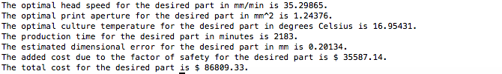

**Figure 4: Dimensional Error vs. Print Aperture**

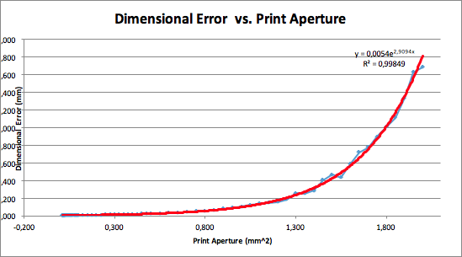

**Figure 5: Dimensional Error vs. Culture Temperature**

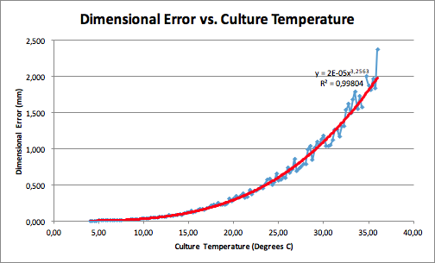

**Figure 6: Dimensional Error vs. Print Head Speed Graph**

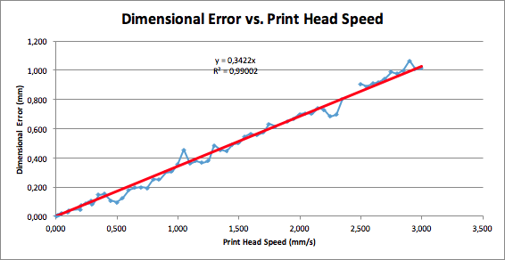

**Table 1: Factor of Safety Ratios**

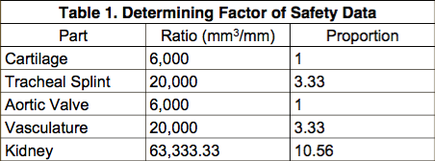

**Table 2: Recommended Operation Settings**

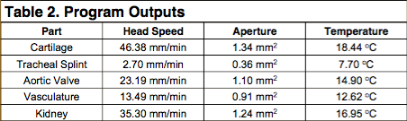

**Table 3: Recommended Operation Settings, Continued**

